Name ______________________

Functions Test Review

**Sketch a graph of the situation below and label each axis appropriately. Provide a written scenario that explains what your sketch is modeling.**

1. Your height above ground as you mount, jump on, and dismount a trampoline.

**EXPLANATION**

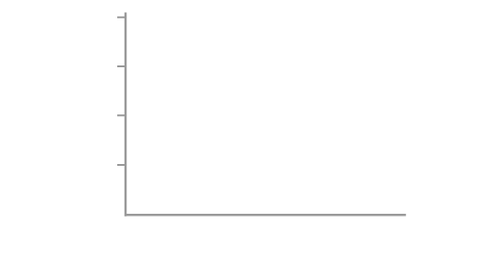

1. Use the graph below to answer the following questions.

|  |  |
| --- | --- |
|  | (a) What was the height of the diving board? WHY?  (b) When did the diver hit the water? WHY?    (c) How deep did the diver get? WHY?  (d) When did the diver return to the surface? WHY? |

1. Are the following scenarios representing function? Make sure you provide an explanation for your reasoning.

**SCENARIO IS IT A FUNCTION?**

|  |  |
| --- | --- |
| http://iwt.wpengine.netdna-cdn.com/wp-content/uploads/2009/05/step-function-guest-post.png |  |
| http://terpconnect.umd.edu/~sandborn/courses/ENME462/Studio3/lab401.gif |  |
| |  |  | | --- | --- | | x | y | | 9 | -2 | | 15 | -1 | | 21 | 5 | | 22 | 5 | |  |
| http://img.sparknotes.com/figures/4/4d7924c96427a340a0f1be4c7e650f7c/rel1.gif |  |
| {(6, 3), (7, -2), (-1, 4), (6, 8)} |  |

1. Evaluate the equation , for . 4. _____________
2. Evaluate the function rule , for . 5. _____________
3. Find the range of the function rule , for 6. _____________

the domain = {-2, -1, 0, 6}. Show work.

1. List the domain and the range of the 7. Domain =

following relation.

Range =

{(1, -6), (-4, 2), (-7, 1), (1, -9), (-8, 0), (5, 4)}

1. Model the rule  with a table of values and a graph.

|  |  |  |
| --- | --- | --- |
| x |  | (x, y) |
|  |  |  |
|  |  |  |
|  |  |  |

1. You really want the newest version of Black Ops for your PS3. You have $30 in your wallet and you receive a $7.00 allowance each week. Write a rule below to describe total cost of the game as a function of the number of weeks you must save your money in order to purchase the game.

Define variables:

Relate:

Function Rule: